Goldilocks and the Three Bears

Whilst at the park or out in the woods, have a go at the following …

In the story how many bowls of porridge did Goldilocks find? _______
Can you find the same number of different leaves?

The number 3 is used throughout the story, you may wish to use the number chart in this pack, which helps your child to visually understand comparison of quantities for each number and concepts such as “more” or “less”. Collect items at the park or from the garden.
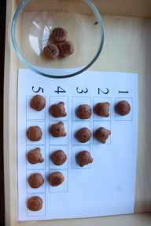

What did Goldilocks say about the chairs? _____________________
Can you show your adult a big tree?
Can you show your adult a small tree?

Goldilocks found the first bed too hard and the second bed too soft, can you find something hard and something soft in the park/wood?
You may wish to continue using the senses to search around the area for items that are rough, smooth, cold to touch or prickly

Whilst outdoors, collect natural resources to make a collage at home, here are some suggestions.
Why not photograph and share your creations on our page/group?

A bear made from leaves 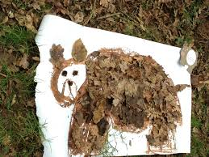

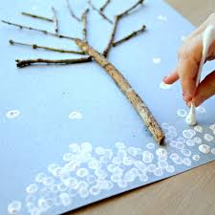 A winter scene

A shelter for your favourite teddy bear or cuddly or a bear hunt …
