Jack and the Beanstalk 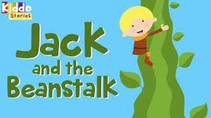

Can you remember, who were the characters in the story? _________

Talk with your child about the story and see how much they remember.

Then have a go and these activities and let us know how you get on …

Whilst at the park, in the garden, out in the woods or at home, have a go at being a ‘magic bean’ – use these ideas below with your child :
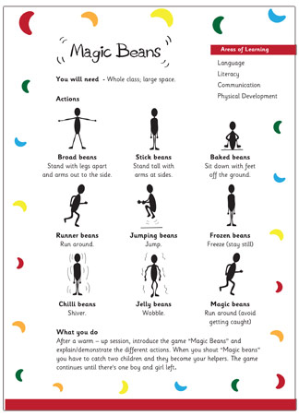

Jack got given some magic beans which he threw away and they grew into a huge beanstalk.
Use things around the house to build your own beanstalks and find ways of measuring them – you could use cushions, cubes, Lego or Duplo bricks, books, carboard boxes or play dough perhaps?
Talk to your child about which is the smallest, shortest, tallest, and biggest ‘beanstalk’.
Why not have a go at making your own play dough?
1. 2 Cups flour
2. 1 Cup water
3. ½ Cup Salt
4. 2 tablespoons oil
5. Food colouring ( as much as you need to get the colour you want)
6.Optional - to make scented dough add herbs or spices (grated cloves, ground ginger, ground cinnamon, grated nutmeg, etc).
7. Mix it together with a wooden spoon to avoid staining your hands with the food colouring.

Plant some seeds. If you do not have seeds at home to plant, watch this 3-minute clip of a kidney bean time lapse over 25 days
https://www.youtube.com/watch?v=w77zPAtVTuI&t=27s
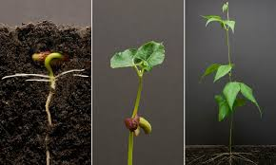

Design your own magic beans or beanstalk using any materials you can find. You could use pens, paper, tin foil, buttons, string… anything to make your bean look magical! Use your hands to make the picture of the giant.
Use natural resources, collect some leaves from the park, wood, or garden.
Write numbers on the picture leaves to practice counting.
Use seeds to practice counting, or dried pasta perhaps?

