The Three Little Pigs

Do you remember how many pigs are in the story? How many? _______
Can you collect the same number of different size sticks?

How many big bad wolves are in the story? ________
Can you show your adult the tallest and biggest tree in the park?

In the story the three little pigs were busy building a home – do you remember what they used to make their homes? (straw, brick, wood) _____________

Which houses did the wolf blow down? ____________________________

What might blow away in the park? ____________________________

What is strong and will not blow away in the park? ___________________

Whilst at the park or wood have a go at making a shelter, here are some ideas:
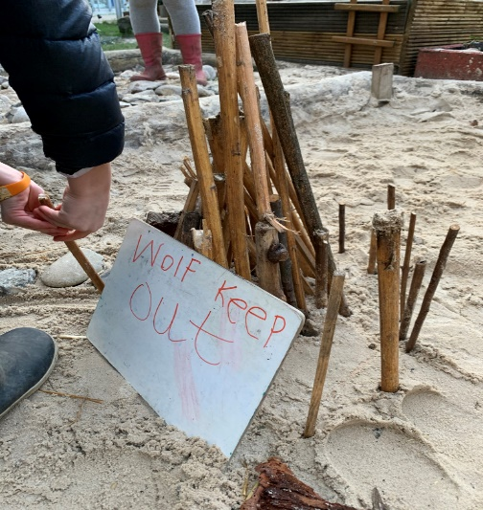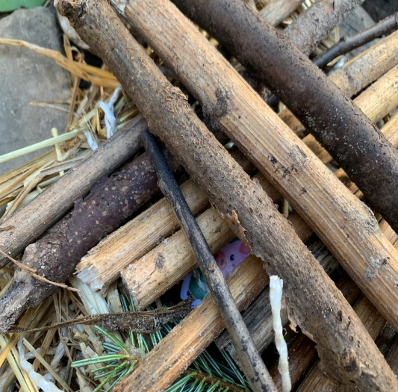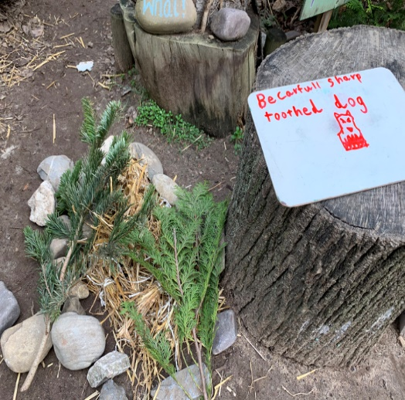

Science and Exploration
Collect some objects and see which ones move when you blow them?
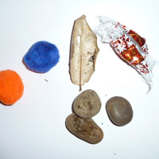

Depending on the age of your child, there are a few ways you can go about introducing them to the human respiratory system.
Teach them simple concepts about their lungs.
Some things might include:
- we have two lungs
- the lungs are in our chest
- our lungs are pinkish red and squishy
- we use our lungs to breathe

Make a collage or picture:
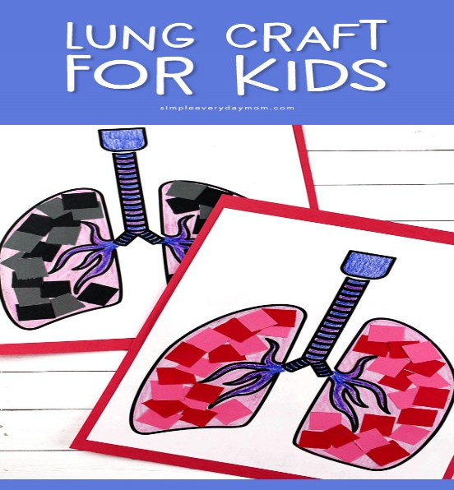

ART AND CRAFT IDEAS
Following the interests in the story of The Three Little Pigs, use straws to ‘huff and puff’ into them to create pictures. See the paint run into the paper to make some interesting art.
We do not always need paint brushes to be creative with art.
Blow Painting Steps
- Set up a tray with a heavy sheet of paper.
- Place a few bowls filled with a bit of liquid watercolours nearby. Place a pipette in or next to the watercolours.
- Invite your child to draw watercolour paint into the dropper and then squeeze it on the paper.
- With a straw, blow the paint around the paper.

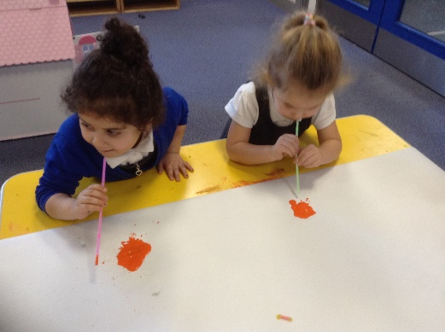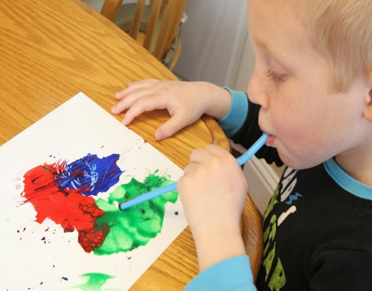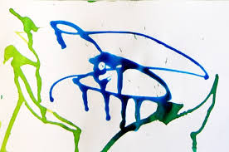

Whilst at the park or in the woods, collect some natural resources to recreate the houses in the story and use resources from home. Here are some ideas :
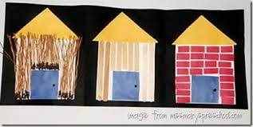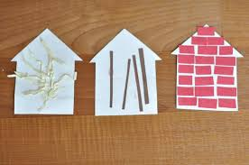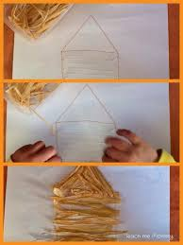
Or perhaps you have bricks for building?
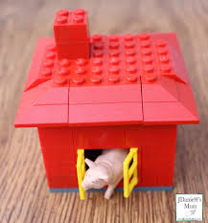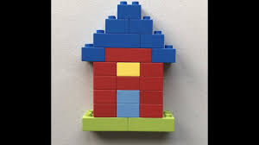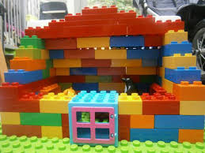

Why not photograph and share your creations on our page/group?

